ZOMATO RESTAURANT ANALYSIS
1.Project Overview
This project involves an in-depth Exploratory Data Analysis (EDA) of the Zomato Bangalore Restaurants Dataset to identify key trends, customer preferences, and performance drivers within Bangalore’s restaurant ecosystem. Using Python-based data analysis and visualization techniques, the project examines the impact of pricing, ratings, restaurant types, cuisines, locations, and service availability (online ordering and table booking) on restaurant performance. The analysis includes data cleaning, preprocessing, non-graphical analysis, and visual exploration to derive meaningful business insights.
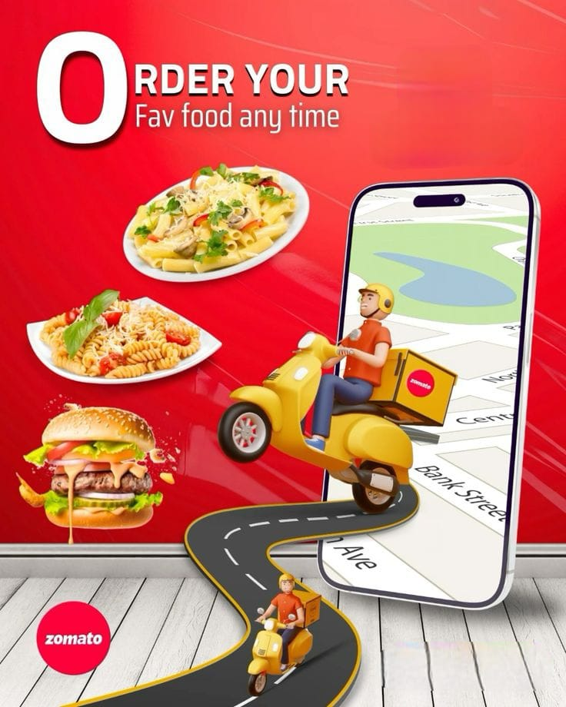
The findings aim to support data-driven decision-making for Zomato and restaurant owners by identifying factors that influence customer engagement and overall restaurant success.
2.Business Context
Zomato is a leading restaurant discovery and food delivery platform in India, enabling users to explore restaurants, compare ratings and pricing, place online orders, and book tables. With thousands of restaurants listed across Bangalore, Zomato operates in a highly competitive market where customer preferences and restaurant performance vary significantly by location, pricing, cuisine, and service type.
To remain competitive and drive growth, Zomato must make data-driven decisions on:
1.Which restaurants should receive higher visibility and promotion
2.Whether to prioritize delivery-based or dine-out services
3.Which locations and cuisines generate higher customer engagement
This analysis leverages the Zomato Bangalore restaurant dataset to uncover patterns in ratings, pricing, services, and customer behaviour. The insights generated help Zomato improve platform visibility, enhance customer experience, and support restaurant partners in optimizing their offerings for better performance.
3.Problem Statement
Bangalore’s restaurant market is highly competitive, with restaurants differing significantly in terms of pricing, ratings, cuisine offerings, location, and service availability. Despite being listed on the same platform, restaurants do not perform equally in terms of customer engagement and ratings.
The key business problem addressed in this project is:
How can Zomato and restaurant owners leverage data to identify high-performing restaurant types, services, price ranges, cuisines, and locations in order to make informed decisions on promotion, expansion, and service optimization?
4.Project Objectives
The primary objectives of this project are to:
- Perform exploratory data analysis to understand the overall restaurant landscape in Bangalore, including distribution across locations, restaurant types, and service categories.
- Analyse and compare delivery-based and dine-out restaurants to identify platform focus and customer preference patterns.
- Evaluate the impact of pricing, service availability (online ordering and table booking), and restaurant type on customer ratings and engagement.
- Identify high-performing locations and popular cuisines based on ratings, votes, and restaurant density.
- Transform analytical findings into data-backed business insights and actionable recommendations for Zomato and restaurant owners.
5.Dataset Description
Dataset Name: Zomato Bangalore Restaurant Analysis Dataset
Total Records: 51,717
Total Columns: 17

Main Key Columns:
Column Name | Description
online_order | Online ordering available(yes/no)
book_table | Table booking available(yes/no)
Rate | Restaurant rating (text format like 4.1/5, NEW, -)
Votes | Number of votes
Location | Restaurant location in bangalore
rest_type | Types of restaurant
Cuisines | Cuisines served
approx_cost (for two people) | Cost for two people
listed_in (type) | Delivery/dine-out
The dataset contains missing values, text-based numerical fields, and inconsistent formats, requiring preprocessing.
6.Data Cleansing & Pre-Processing
- Data Quality Checks
- Verified dataset shape and column types
Identified missing values in:
1.Ratings
2.Cuisines
3.Restaurant type
Cleaning & Transformation:
1.Converted rating column from (4.1/5, NEW, -) – numeric format
2.Converted approx_cost (for two people) to numeric
3.Converted categorical columns to category data type
4.Removed duplicate records
These steps ensured the dataset was analysis-ready and reliable.

7. Dataset Profiling, Data Quality Assessment & Exploratory Data Analysis
1. Problem Statement & Basic Metrics
1.1 Business Objective (Zomato Perspective)
Zomato operates as a restaurant discovery and food delivery platform. Its core business objective is to connect customers with restaurants efficiently, while maximizing order volume, customer satisfaction, and restaurant visibility.
From a business analytics perspective, understanding:
- The size of the restaurant ecosystem.
- The availability of delivery vs dine-out services, and customer access to these services is essential for strategic decision-making, market expansion, and service optimization.
This project aims to analyse Bangalore’s restaurant landscape using Zomato data to support data-driven business insights.
1.2 Total Number of Restaurants
The dataset contains approximately 51,490 restaurants listed across Bangalore.
This indicates:
- A highly competitive food service market.
- A strong participation from both small outlets and large restaurant chains.
- A mature ecosystem with diverse cuisines and formats.
Understanding the total number of restaurants helps Zomato assess market density and competition intensity.
1.3 Distribution: Delivery vs Dine-Out
Restaurants in the dataset are categorized based on service availability:
Delivery-enabled restaurants
Dine-out–only restaurants
Restaurants offering both services
Key observation:
A significant majority of restaurants support online delivery.
Dine-out–only restaurants form a smaller portion of the market.
This highlights Zomato’s strong positioning as a delivery-focused platform, reflecting changing customer preferences toward convenience and online ordering.
2. Data Overview & Quality Check
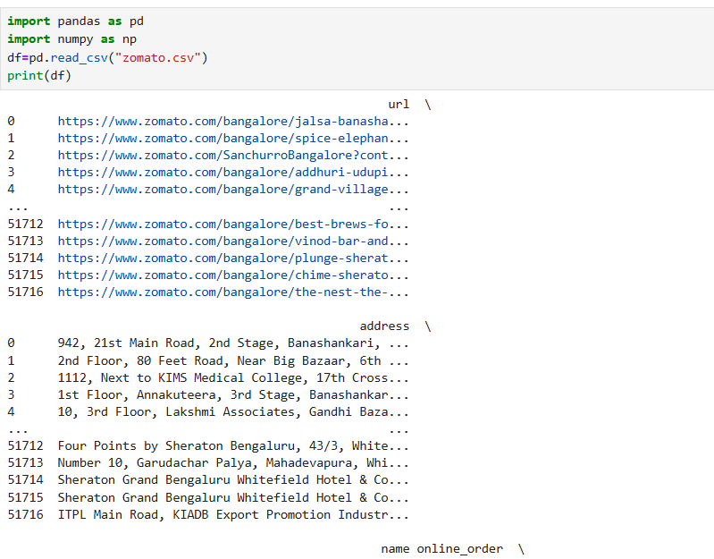

2.1 Shape of the Dataset

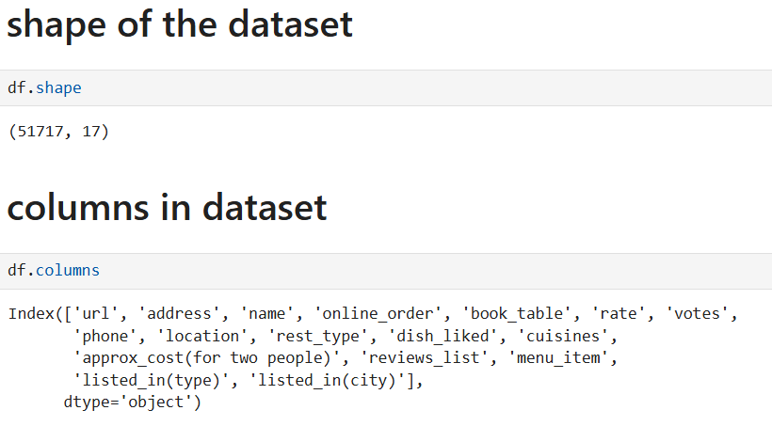

2.2 Data types of all columns
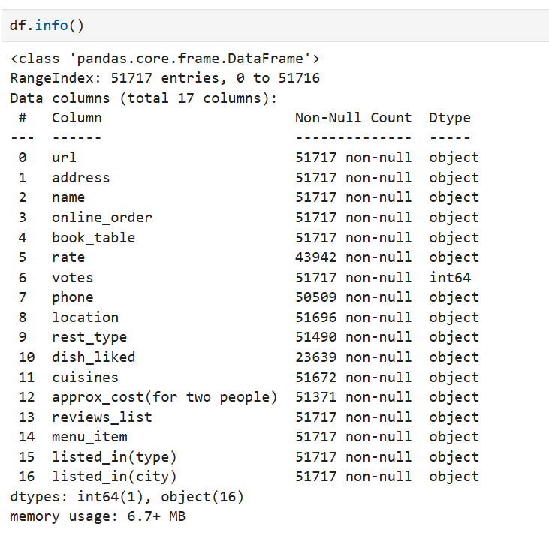

2.3 Conversion of categorial columns to category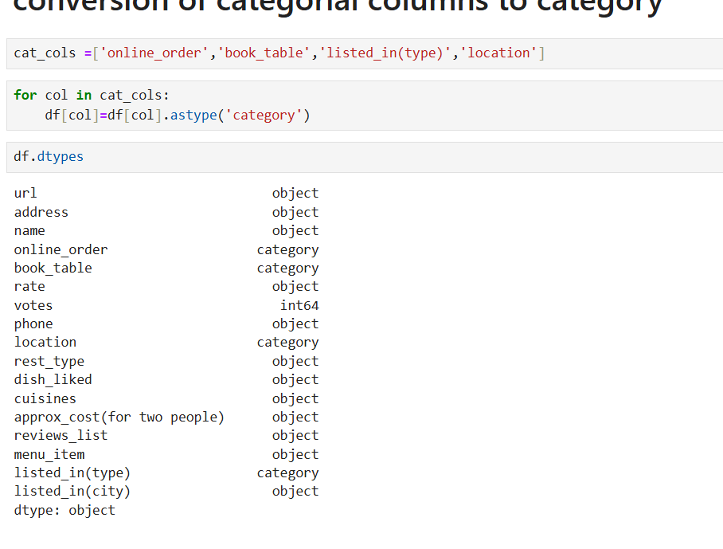

2.4 Missing values detection
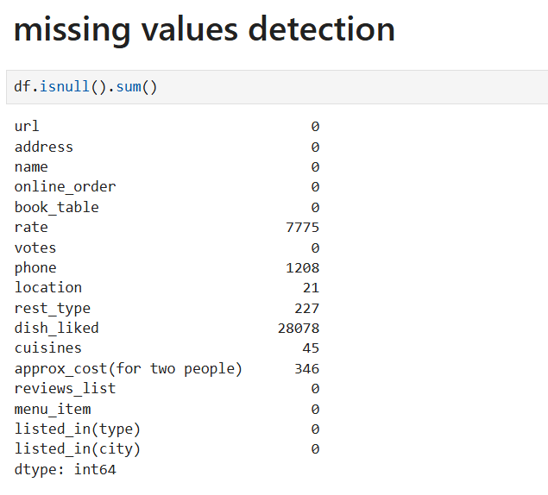

2.5 Statistical summary of numerical columns
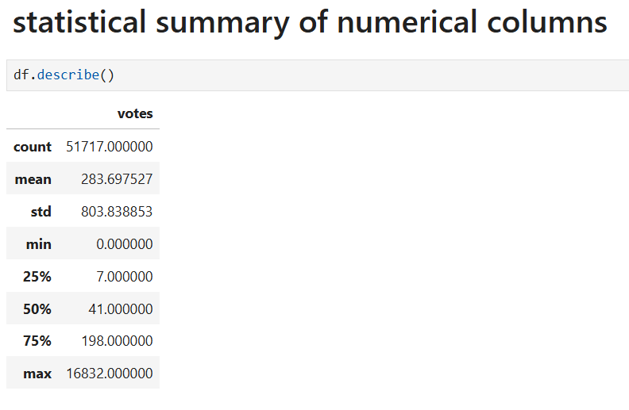

3. Non-Graphical Analysis
3.1 Value Counts of
- Online Ordering
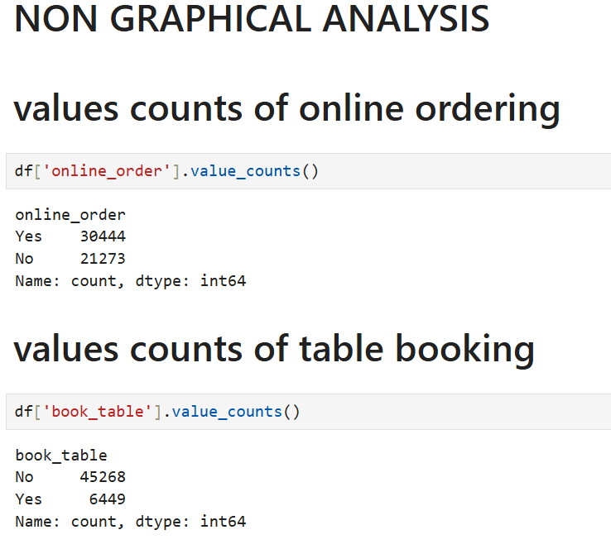

- Table Booking


- Restaurant types
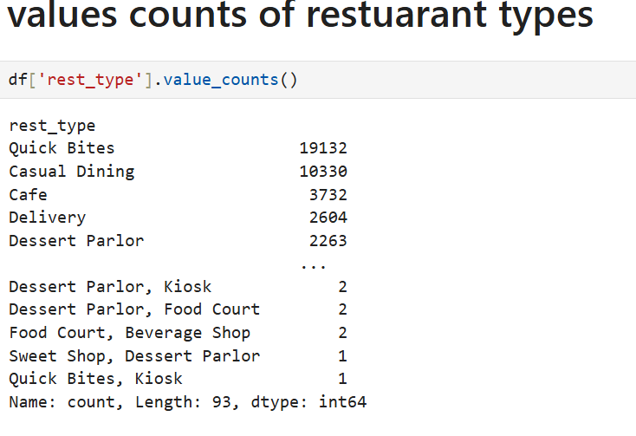

- Locations
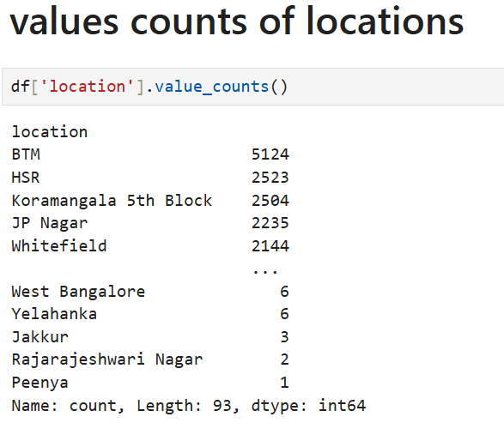

3.2 Number of unique cuisines and locations
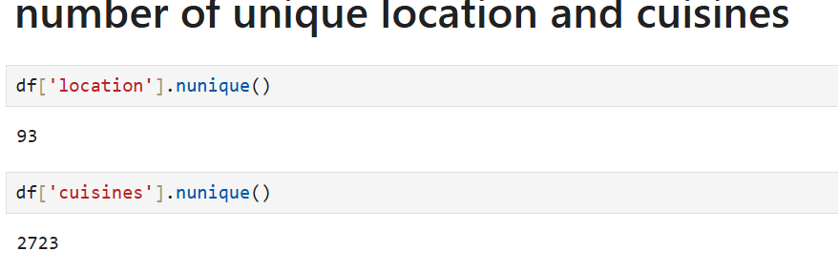

4. Visual Analysis (Pre – Processing)
- Cleaning rating column
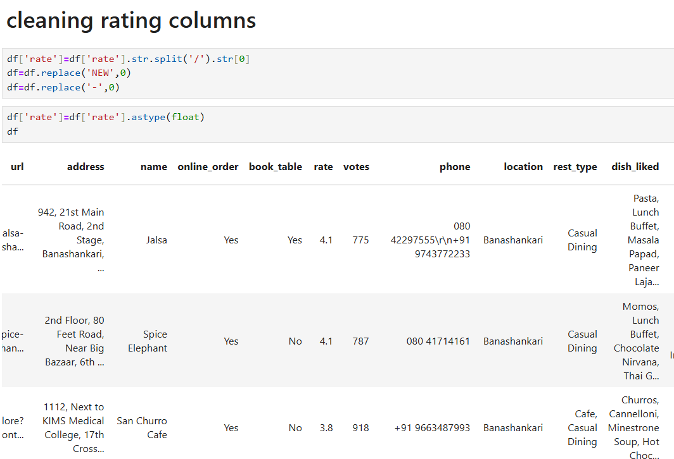

- Converting cost column to numeric
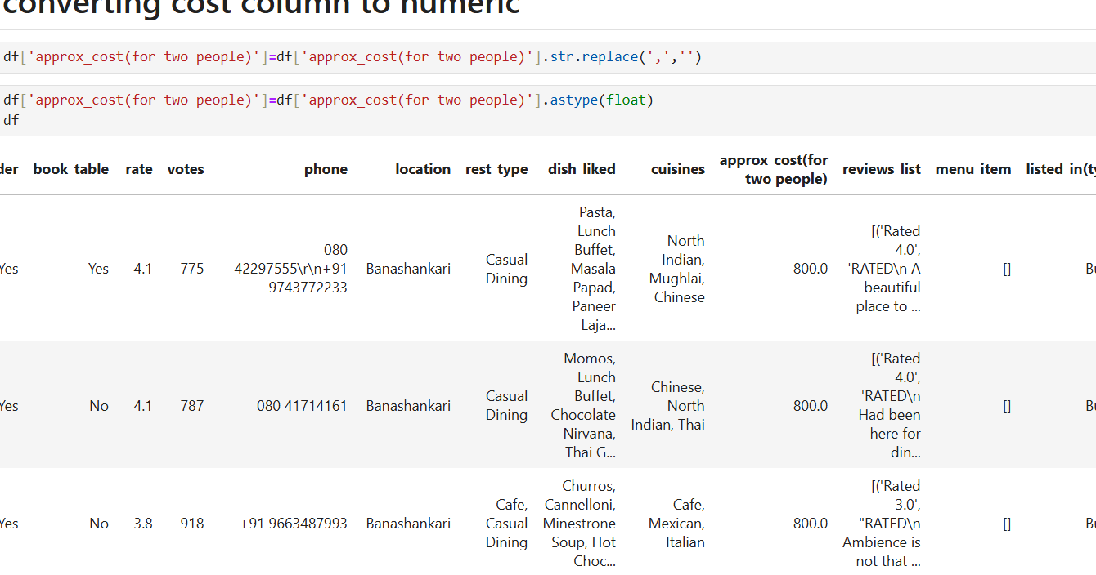

- Removing duplicates
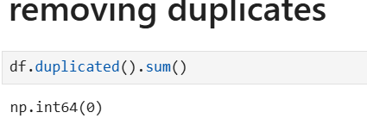

  - UNIVARIATE ANALYSIS – Continuous Variables
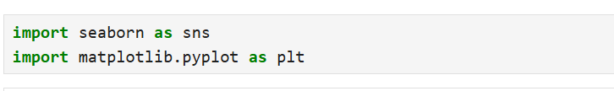

- Histogram plot
For Ratings:
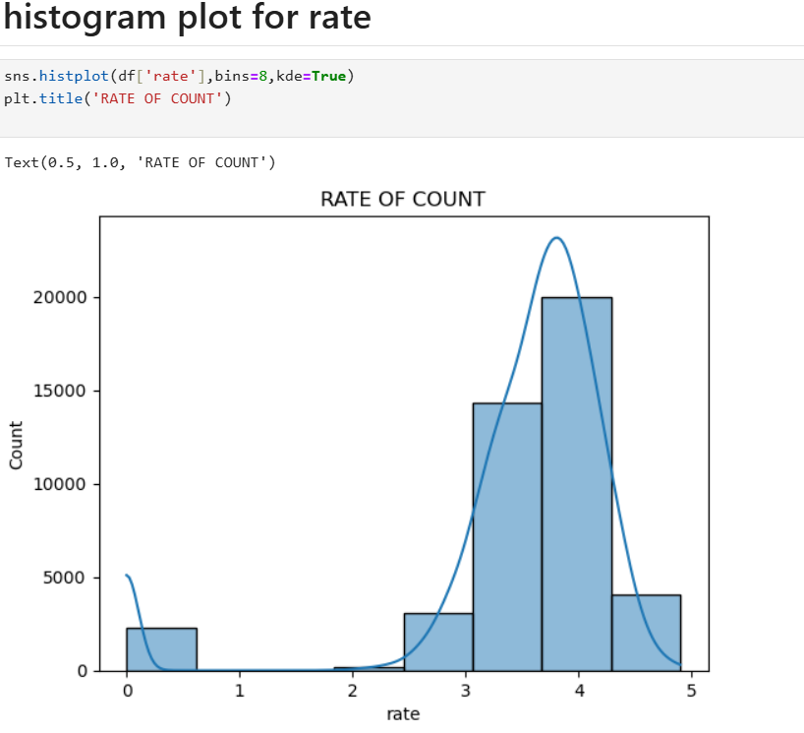

For Cost for two:
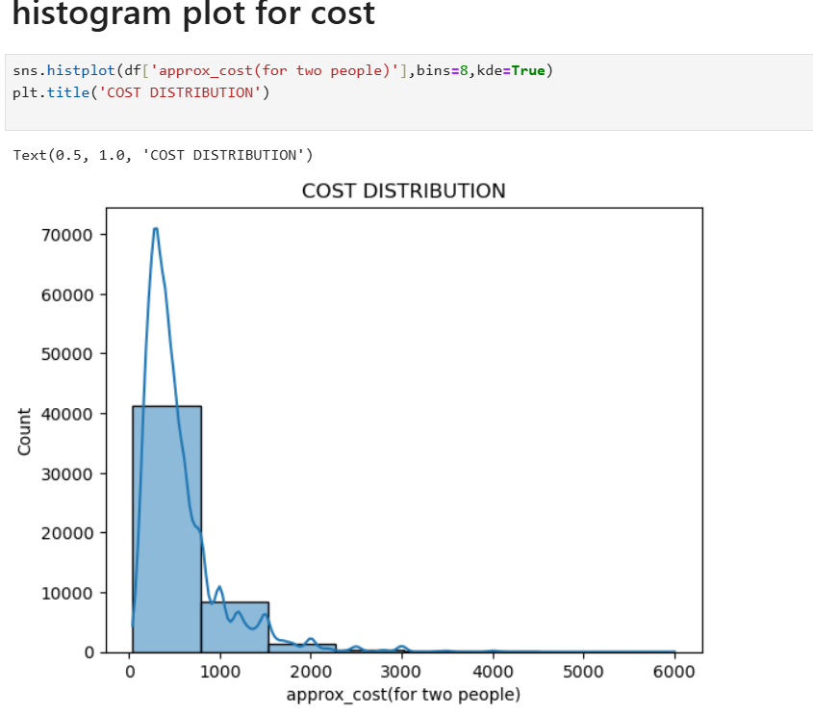
For Votes:
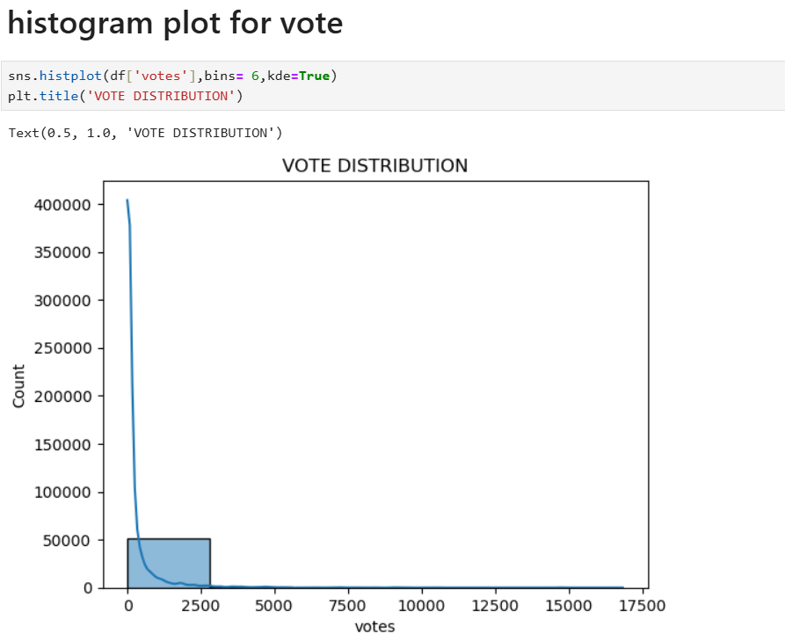

  - BIVARIATE ANALYSIS – Categorial vs Variables
- Box plot
Rating vs Online Order:
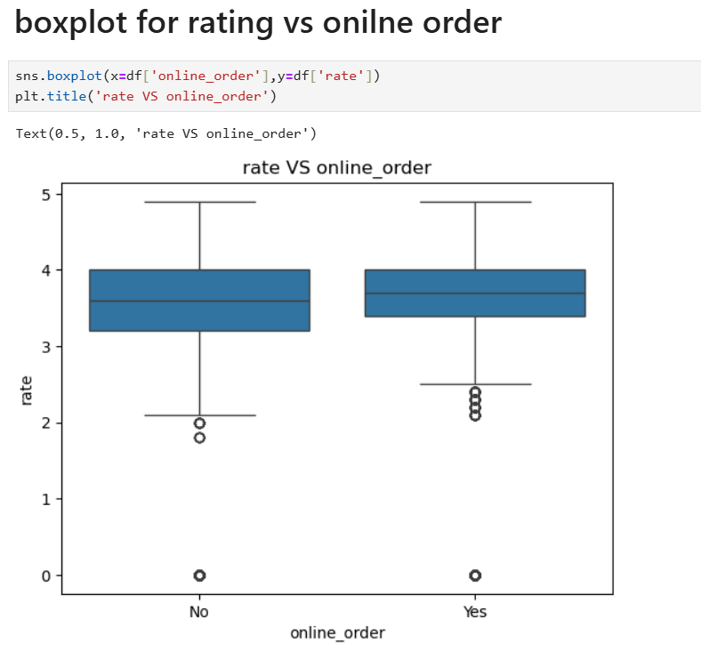

Rating vs Table Booking:
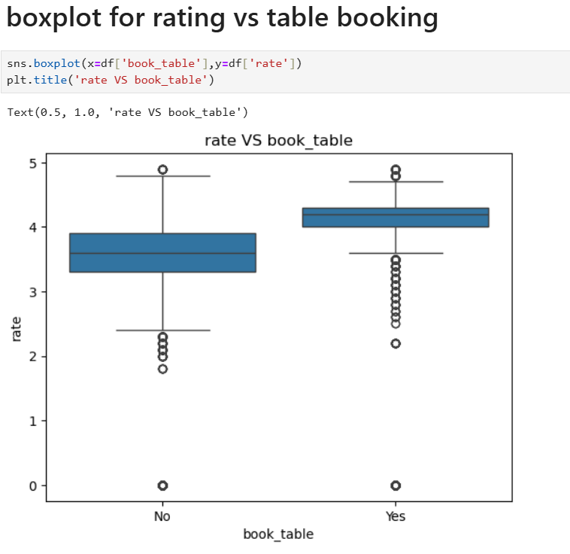

Rating vs Restaurant Type:
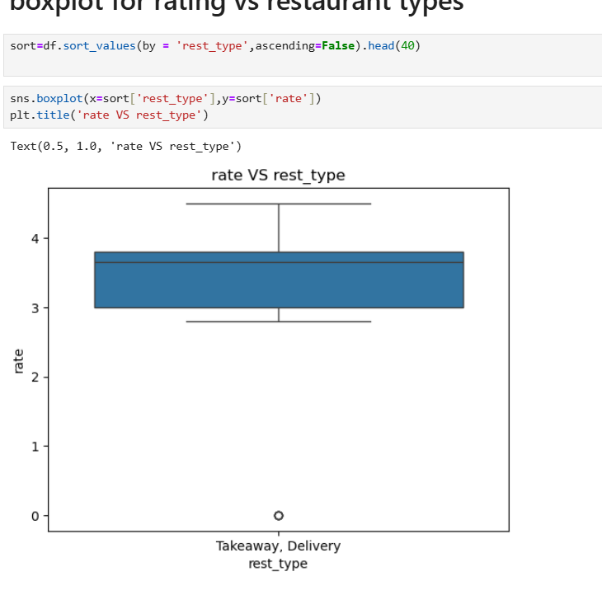
Rating vs Top Locations:
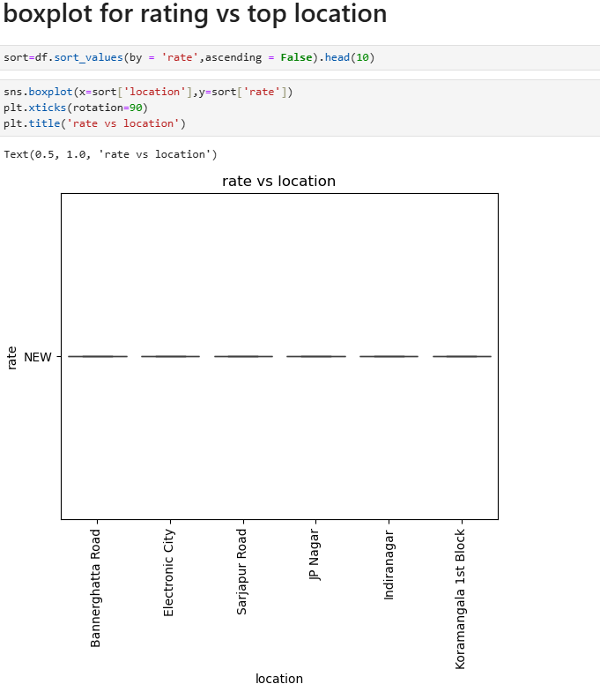

5.Missing Values & Outlier Analysis
5.1 Identification of missing values in Rating, Cuisines and Restaurant
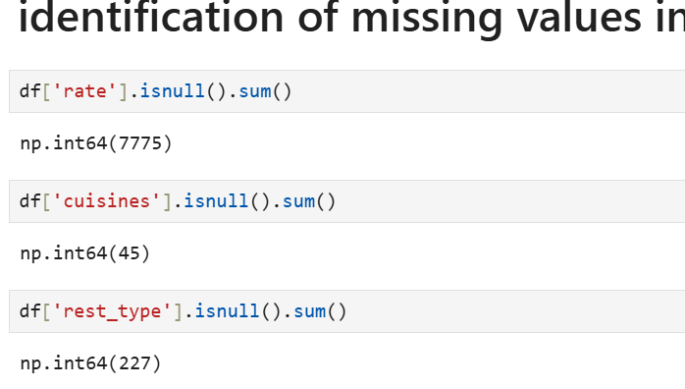

5.2 Outlier Detection
For Cost:
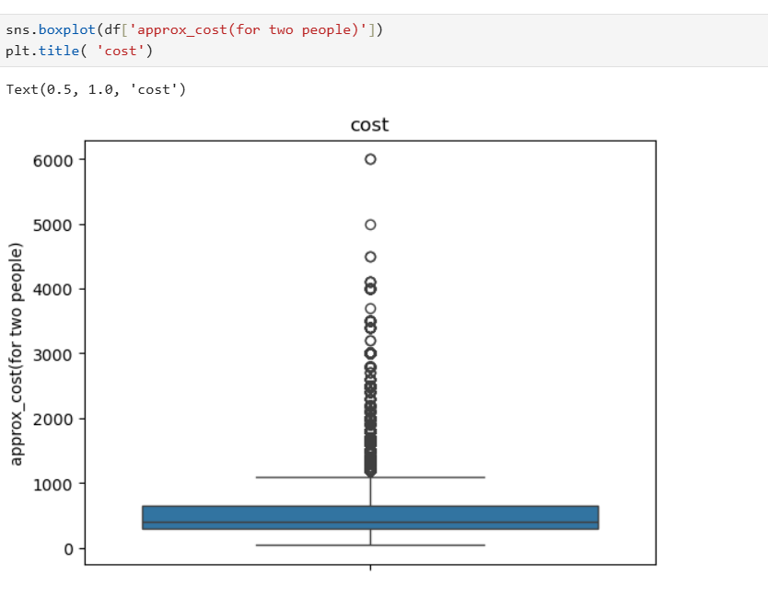

For Votes:
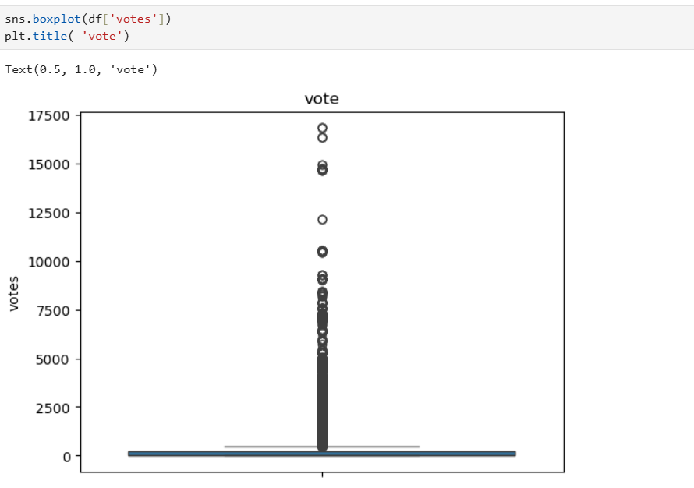

6. Insights from Analysis
6.1 Range of Attributes
- Ratings
- Most restaurants rate 3.5–4.5, very few exceed 4.7.
- Low ratings (<3.0) are rare.
- Insight: Service and experience are key differentiators.
- Cost
- Cost ranges from ₹100 to ₹2000+.
- Majority fall in ₹300–₹800 range.
- Insight: Market is price-sensitive and value-driven.
- Votes
- Votes are right-skewed.
- Few restaurants get very high votes.
- Insight: Votes reflect visibility and customer engagement.
6.2 Distribution & Relationships
- Cost vs Rating
- No strong link between price and rating.
- Mid-priced restaurants often rate high.
- Insight: Value-for-money matters more than price.
- Service Type
- Delivery restaurants have higher votes and stable ratings.
- Dine-out only shows more variation.
- Insight: Delivery increases reach and consistency.
6.3 Plot-Wise Observations
- High competition in ratings (3.5–4.2).
- Budget & mid-range dominate.
- High ratings exist at all price levels.
- Delivery + dine-out performs best.

- Key Business Insights
- Market Size & Mix
- ~51K restaurants across 93 locations.
- Dominated by Quick Bites & Casual Dining; niche formats include Cafes and Delivery-only.
- Customer Channels
- Online ordering is widely used.
- Table booking adoption is limited.
- Location Concentration
- High density in BTM, HSR, Koramangala, JP Nagar, Whitefield.
- Several outer areas are under-served.
- Pricing
- Costs are right-skewed.
- Most restaurants fall in low–mid price ranges; premium segment is small.
- Ratings & Votes
- Ratings mostly between 3.0–4.5.
- Votes are highly skewed with few high-visibility brands.
- Online Order & Booking Impact
- Restaurants offering online ordering or table booking show slightly higher median ratings.
- Cuisine & Format Diversity
- 2,700+ cuisine combinations and 90+ formats, enabling niche positioning.
- Data Quality
- Missing ratings and extreme cost/vote outliers required data cleaning and transformation.

- Recommendations
- Enable online ordering and table booking to improve reach and ratings.
- Enter under-served areas using cloud kitchens or compact outlets.
- Compete on value in price-sensitive zones or clearly position as premium.
- Expand high-rated outlets; improve low-rated ones using customer feedback.
- Focus on Quick Bites & delivery in dense areas.
- Place Casual Dining in established food hubs.
- Invest in high-rating, mid-vote outlets.
- Run cuisine–location targeted campaigns.

